



(Online Airline Ticket Reservation System)

FINAL PROJECT REPORT

URL: http://acrux.cis.ksu.edu:8080/start.jsp

PDA’s URL: http://acrux.cis.ksu.edu:8080/home.wml

AVINASH PONUGOTI
NAGARJUNA NAGULAPATI

SATHISH KUMAR REDDY YENNA

1. PROJECT’S MOTTO

The main aim of the project was to develop a website which would facilitate the reservation of online air tickets through an effective and yet simple GUI for a normal passenger intending to travel in airways. Apart from reserving tickets, through our system a passenger can compare online fares ‘from’ various cities ‘to’ various cities.

2. INTENDED AUDIENCE

- The project is basically targeted at those people who would like to travel through air and have an Internet access.
- As we will be making our site WAP – enabled, this will facilitate our site to accept requests from other alternative devices like PDA’s and WAP-enabled browsers. Apart from the above category of audience, passengers using hand-held devices will be our second major category of audience.
- Finally passengers curious in comparing the prices for various Airlines for their selected source and destination cities form our third category of audience.

3.COOL FEATURES OF OUR SITE:

1.Dynamic Bandwidth Calculation:
We dynamically calculate the user’s bandwidth and redirect him to either to the Graphical Version or to the Text-Version based on the client’s bandwidth.

2.Sitemap:
We are providing a cool map of our entire site for easy access of our pages. Sitemap includes all the links in all the pages in our site categorized based on the functionality of the pages.

3.Flash Images of Flights:
We created flight detail images and used Flash to integrate them and show the user the seating arrangement of the flight. The user can know about the details of the seating arrangement, emergency exit doors and lavatory details before entering the flight.

4.Airport Layouts:
We are showing the airport layouts so that the user can know the airline counter details prior to his arrival at the airport. He can directly go to the counter concerned to collect his travel tickets.

5.Points Based System:
We are giving discounts to the regular customers shopping on our site based on points he achieved. One percent of discount is given on present transaction for each $1000 previous transaction amount with a maximum of 20 percent. This will attract regular travelers to use our site instead of others.

4.TECHNOLOGIES USED.

Following are the core technologies used in developing our website.

A. Server Technologies:

WEB SERVER :

- Tomcat Server

  - Tomcat is enterprise class, robust web server which comes bundled with JavaServlets and JSP that provides a java application server environment

  - One of the other major issues why we chose Tomcat was Scalability. Presently Java is our core technology used for portability and in future if we want to make our site be reachable to users using Microsoft products we would be having no conflicts between the servers because Tomcat can be deployed as either a standalone product with its own internal Web server or in conjunction with several other Web servers, including

Netscape Enterprise Server.
Microsoft Internet Information Server.
Microsoft Personal Web Server.

  - It adheres to the latest standards, which expands the security features.
Configuration, tuning and maintenance are lot easier than compared to other prevailing web servers.

  - Since we were not going for enterprise java beans in our project we didn’t feel the necessity of going for other application servers like J2EE or JBOSS .We were basically looking for a reliable web server which would be compatible with both the front-end and back-end technologies we were using and our ultimate choice was Apache’s Tomcat Web Server.

DATABASE SERVER :

- Oracle Server

We are listing the four main reasons why we have used Oracle instead of any other prevailing database servers

- SCALABLE

Oracle supports the largest databases, which can contain terabytes of
data. To make efficient use of expensive hardware devices, Oracle
enables full control of space usage. Even though we want to extend our
site to incorporate upcoming various Airlines database we would be
having no problems at all in extending our database.

- RELIABLE

For now, since our website is not a full-fledged corporate website we are estimating that there would be a maximum of 150-200 hits per day including from all the above mentioned categories of audience who come to our site either to make an online reservation or to compare the prices of various airlines.

Oracle supports large numbers of concurrent users executing a variety
of database applications operating on the same data. It minimizes data
contention and guarantees data concurrency. This definitely helps
us make our website robust and accessible to many number of users
simultaneously. In future even though users increase there would be no
problem on overall.

- SECURE
One of the major concerns about our database were the security issues as we would be maintaining tables to store user information like his user-name, password and personal information like credit card details. We had this extra overhead of maintaining all this information securely and at the same time transparent to the user. We have no regrets now for choosing Oracle as our database server.
To protect against unauthorized database access and use, Oracle provides security features to limit and monitor data access. These features make it easy to manage even the most complex design for data access.

- OTHER REASONS
Based upon the functionality of our website, it obvious that we have to be in a position to handle requests from users accessing our website from various different types of computers and operating systems. Oracle software enables different types of computers and operating systems to share information across networks. Even in future if we want to jump into distributed environment/network we can do so. For networked, distributed environments, Oracle combines the data physically located on different computers into one logical database that can be accessed by all network users. Apart from these reasons, Oracle software lets you replicate groups of tables and their supporting objects to multiple sites. Oracle supports replication of both data- and schema-level changes to these sites.

B. Software Technologies:

- Java Server Pages (JSP)
- Java Servlets
- Java Beans
- JavaMail
- XML & XSL
- HTML
- WML
- JavaScript
- HTTP Sessions
- Java Bean

Java Server Pages (JSP)
- Regular HTML, of course, cannot contain dynamic information. JSP is so easy and convenient that it is quite feasible to augment HTML pages that only benefit marginally by the insertion of small amounts of dynamic data.
- JSP was designed to work with Java Servlets and JavaBeans in a seamless fashion, it provides applications developers with the capability to cleanly separate content generation from content presentation.
- This means that Web page designers can work independently from business logic developers, and the end result will work in a distributed, heterogeneous computing environment.

Java Servlets

- Java Servlets are server-side technologies that provide a component-based, platform-independent method for building web-based applications. They provide web developers with a simple, consistent mechanism for extending the functionality of a web server and for accessing existing databases. Since our website was more database-centric we found servlets as more appropriate choice.

- Servlets have access to the entire family of Java APIs, including the JDBC API to access databases. Servlets can also access a library of HTTP-specific calls and receive all the benefits of the mature Java language, including portability, performance, reusability, and crash protection.

- Our other alternative for Java servlets was CGI. But we continued with Java servlets mainly because of the following reasons
i) Efficient: With traditional CGI, a new process is started for each HTTP request. With servlets, the Java Virtual Machine stays up, and each request is handled by a lightweight Java thread, not a heavyweight operating system process.
ii) Convenient: Each one of us was more comfortable with Java Besides the convenience of being able to use a familiar language, servlets they have this added advantage of automatically parsing and decoding HTML form data, tracking sessions, and many other such tasks. As these operations were very much needed for our website we found our decision to be right.
iii) Powerful: Java servlets let us do several things easily, which are either difficult or impossible by traditional CGI. One thing is servlets can talk directly to the Web server (regular CGI programs can't). This simplified operations that needed us to look up data stored in standard places. We found them very useful in maintaining information from request to request, simplifying things like session tracking and caching of previous computations.

JavaMail

- Hosting an Online Air tickets Website we had this requirement of sending out an email to our customer once he purchased ticket through our site as a confirmation with his flight details and schedule. As we were using Java as our programming language we had this added advantage of using JavaMail API to suffice our need.

- We implemented this feature of sending out emails using JavaMail successfully. For this we had to download Javamail API and JavaBeans activation Framework apart from setting their paths in our webservers classpath. JavaMail API allowed us to instantly add the ability to send-out e-mail with our Java applications with negligible programming effort.
XML & XSL
- XML was mainly used because of its extensibility feature. It had this added advantage of presenting the same content in different formats to different clients.
- Our site is completely driven by XML data. We have implemented all our servlets in such a way that they throw XML DOM tree for each and every page. So once we had this XML DOM tree in hand we implemented XSL’s to throw out either a HTML data or WML data to the client depending on either the request coming from http browser or WAP browser.
- In this way our site is more extensible, suppose that in future we had to extend our site to clients with a new markup language what all we need to do is write out a separate XSL to display the data in the form specific to that client.
- Another major advantage of sending XML data to the client instead of html data is, we can offload some computation to the client from the server. i.e. we weren’t forced to bother about the presentation data on the server's side, instead we concentrated on sending the data and using style sheets to display it in according to the client’s needs.
WML
- Our site is PDA enabled. We used WML to make our site accessible through handheld devices.
- WML is the basic mark-up language for the alternate web-access devices.
JavaScript
- JavaScript was basically used for client-side validation.
- JavaScript is compatible with all versions of Microsoft Internet Explorer and Netscape Navigator.
- We have small java scripts, which are lightweight and will not hinder the download time of the HTML document significantly.

HTTP Sessions& Java Beans:
Every user who logs in to our system is given a new session. We implemented this feature using the Http Session API provided by the Servlets and Java Beans.

5.SYSTEM ARCHITECTURE:

A. Architecture Model Used:
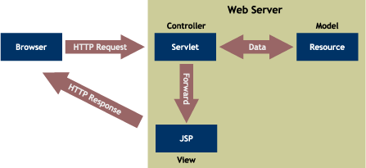

B. Overall Architecture:

Webserver
server
Database Server
Database Server
Database Server
Our System
Database Server

Internet
User

C. Detailed Architecture:

DataBase of Airlines

Our DataBase

Servlets Java Beans

XML DOM Tree

XSL STYLE SHEETS

WML

HTML, JAVA SCRIPT, APPLET

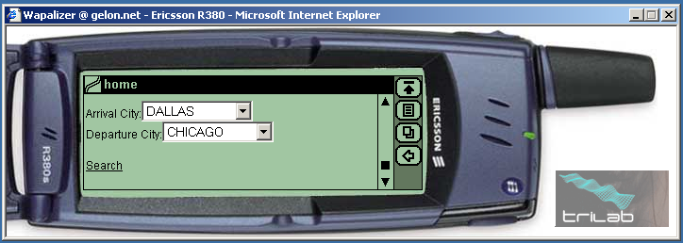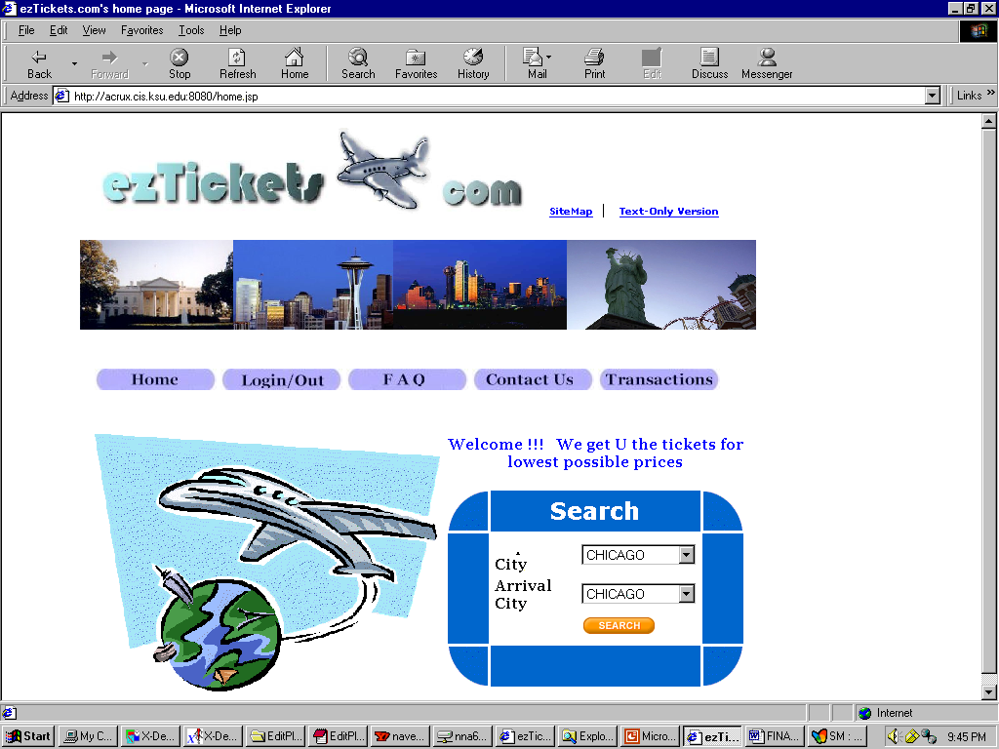

In the Design of our website we made an assumption that we are accessing the database of different airline to get the flight information. Any last minute changes to the flight schedule are taken care by the respective airlines. Presently we are accessing database of three airlines. In our website we will be maintaining the table to hold user information, his transaction details only.

The figure shows how our website is organized. The Servlet accesses the Database, which use the bean. The Servlet generates a DOM tree, which contains the required information. This XML it transformed in to a code containing HTML, JAVASCRIPT code. Which is displayed to the user in a web browser. In case of a PDA device WML code is generated by the XSL.

We are using an Applet to encrypt to user credit card and password information.

6. CONTROL FLOW IN A TYPICAL USER SESSION:

      - User will type the URL of our site: eztickets.com in the browser.
      - User will be shown our homepage containing various page links and search option.
      - User will click on the Login button to log on into our system.
      - The user-id and password are validated and the user is allowed to login.
      - The user is directed to the home page where he can start his search for his travel options.
      - The user can select the Departure and arrival cities and click on the Search button.
      - The user will be shown a page with various list boxes he has to choose for his tickets.
      - The user will select the departure airport, arrival airport, departure date, arrival date, and number of tickets and will click on the Search button again.
      - The user is presented with page listing all the options for his search criteria.
      - The user can select one of the options and click on the Buy button.
      - The user will be shown the details of the option and the discount offered to him on his selection for his confirmation.
      - The user can click on the Confirm button or can cancel even at this point.
      - If he chooses to buy this ticket he will be sent E-mail with all details of the tickets and is shown a page with a link to the flight seating arrangement details page.
      - User can click on that link and go to the Flight seating arrangement details page.
      - He can click on the link corresponding to his flight number to see the seating arrangement of his flight.
      - User can either continue shopping or close his session by logging out of the system.

7. DATABASE DESIGN:
We use Oracle as the backend and use JDBC connectivity to access the database. The servlets access the database using JDBC and output the results according to the query, which again takes into account the options, selected by the user.
The following gives the various tables and their fields used in our database, which was a major design decision of our project.
USERS Table contains the details of the users registered for our services. The fields in this table are as follows:
USERID PASSWORD FNAME LNAME SSN ADDRESS CARDTYPE CREDITCARD EXPMONTH EXPYEAR POINTS
USERID is the PRIMARY KEY of this table.
TRANSACTIONS Table contains the details of all the transactions done by the users through our site. The table contains the following fields:
TNO USERID TDATE OFNO DDATE DAIRLINE DCITY TICKETS ACITY AAIRLINE RDATE RFNO TOTAL
TNO is the PRIMARY KEY of this table.
NEWS Table contains the details of the current news. This news includes flight cancellations, flight delay information and other important weather information. The table contains the following fields:
HEADLINE HREF
HEADLINE is the PRIMARY KEY of this table and the HREF is the link to the file, which contains the complete data regarding the headline.
MOTELS Table contains the motel information for various cities. The fields in this table are as follows:
CITY MOTEL ADDRESS DELUX LUXURY
(CITY,MOTEL) is the PRIMNARY KEY of this table. DELUX AND LUXURY are the corresponding of the MOTEL.
AIRLINE Table contains the information about the various flight availabilities and the related information. The table has the following fields:
FLIGHT DEPCITY DEPPORT DEPTIME ARRCITY ARRPORT ARRTIME AIRLINE ECPRICE ECSEATS BSPRICE BSSEATS
(FLIGHT, DEPTIME) is the PRIMARY KEY of this table.
We assumed three airline databases in the above format. For that we created three different tables DELTA, UNITED, AMERICAN with the same above schema.

7.SECURITY:
We have been very much successful in implementing the security features to our site as stated in our project specifications. We are enclosing the brief description of how we have carried out this feature.
Password Encryption:
We have used Java Applets for the encryption of the password typed by the user. We implemented the Unix Crypt command for the password encryption. The encrypted password is sent to the servlet. The encrypted password itself is stored in the database table. This will avoid unauthorized users/malicious technical staff from accessing our database. Whenever user tries to login into our system, the password typed by the user is again encrypted and is compared with the encrypted password stored in the database.
Encryption of Credit Card Details:
We have used RSA algorithm for the encryption of the credit card number. When the user gives credit card number in the Registration form, the credit card number is encrypted using a Java Applet implementing the RSA algorithm and is sent to the servlet. The encrypted credit card number is decrypted using the same algorithm and is stored in the database. For all other purposes the server will use the format XXXX-XXXX-XXXX-1234 and send only the last four digits of the credit card. So the sensitive card information is well secured in our system.
Httpsessions:
We have implemented session tracking using HTTP sessions API provided by the servlets. New session is created each time a user logs in and all the information required is stored in the session object. The HTTP session keeps track of the user status and whenever he logs out of the system, the entire data in the session object is destroyed so that other users can’t access his information. More over we are not storing the entire credit card number in the session, only the last four digits are stored. So, even if the user doesn’t close the browser, others can’t access his personal details.

8. HANDICAPPED ACCESS:
Text-Only Version:
We have provided text-only version of our entire website which makes it more accessible to both the handicapped users and low computational powered devices.
ALT Tags:
We have provided ALT tags to all the images and other multimedia content on our website. This will enable the handicapped users to use their screen readers to know about the images on our site.
Sitemap:
We provided a map of our entire website. A hyperlink is given on Home page so that users can click on that link to have the entire sitemap. In this way the users can have a quick glance of our entire site. This will also enable the handicapped users who are unable to find particular page access that page directly from our sitemap.
No Frames:
We have completely avoided using frames on our web pages as these frames avoid screen readers providing information to the handicapped users.
Minimal User Input:
We have taken major steps to minimize the user input. We used Pull Down menus to avoid the user providing the information. User can browse the entire site with very less amount of input. This will attract not only the handicapped users but also the normal users.

9. DISTRIBUTION OF COMPUTATION:
A. Client-side Computation:
Password encryption and Credit Card encryption are done at the client-side using the java applets. This will reduce the server side computation a bit.
Validation of the data entered by the user is done at the client-side using javascripts. This will avoid the users entering invalid data. All the fields either in Registration form or in Login form are checked before sending to the servlet.
As we have designed our Servlets in such a way that they throw out the XML DOM tree, in a way we are able to offload the computation to the client side thereby reducing the overhead on the server side.

B. Server-side Computation:
The server side computations include
- Servlet accessing the database
- Building the XML DOM tree
- XSL transforming the XML data into HTML/WML
We are assuming that at most 500 simultaneous users will access our site at any instance, so this requires high computational powered server. We assumed dual processor web server with each 1.0 GHz power. This will be sufficient for the requirements.
10. MULTIMEDIA:

Inner view of the Flights:

We created various flash videos giving the details of the flights such as:

Statistical details
Seating arrangement Details
Rough Pictorial View of the Flights.

11. FLEXIBILITY:

- Content generation and Content Presentation are separated in our system. We used XML and XSL for achieving this feature. This will enable us to extend our site to new era of alternate web access devices.

- We implemented our system accessing an airline database at the backend. We can extend this to access any number of airline databases as backend information providers.

12. PERFORMANCE RESULTS:

- Since our website doesn’t involve bandwidth occupying images or bitmaps which could unnecessarily take lot of time to load, our loading times for each of the JSP pages are quite decent and fast. Moreover we are calculating the client’s bandwidth dynamically and directing the client to the text version if it has low bandwidth.
- The pages that invoke the servlets (which in turn access the database) to generate dynamic content may take some few seconds to load as the servlet has to establish a connection and then has to query the database. This cannot be avoided in our case and it doesn’t occupy much of a time really.
- The performance result actually depends on the number of users accessing the database. Our optimal case, average case and the worst case all depend upon the number of users trying to connect to the database. The worst case will be when several hundreds of users are accessing the pages, which might cause the database server to crash. Since we create new connection every time a servlet is invoked it could be a case that the connections are used rapidly and it will come to a point where the database server could crash.
- We have around 3 servlets for WML which enables our website to be accessed by hand held devices.

13. IMPLEMENTATION EXPERIENCES:

- We had problems in implementing Dynamic Bandwidth Calculation in our site. We used an Applet to load a fixed-size image from the server to the client in the background. Based on the time taken by the file transmission we tried to direct the user to either Graphical version or the Text version of our site.
- We initially thought of providing the user an option of sorting the results based on his own priority. We started implementing this using java script but we were unable to implement it both in Internet explorer and Netscape navigator. We thought this wouldn’t affect our site’s experience much.
- We initially planned to show the user an animated inner view of the flights but we were unable to create the animated pictures and hence we used flash to show various static images of the flights.
- Initially we installed Tomcat Version 3.4.1 but it was unable to recognize the class path. So we had to move to Version 3.2.4.
- We had many problems with the WAP simulators in passing the parameters dynamically to the servlets. We tried on many available WAP simulators but we were unable to find one for our purpose.
- We had problem with Oracle database population. We thought of providing the user at least one month flight details but because of the constraints on the usage of CIS oracle database space, we couldn’t populate it as we planned.

14. SNAPSHOTS OF OUR SITE:

Graphical Version Home Page
TextVersionHomepage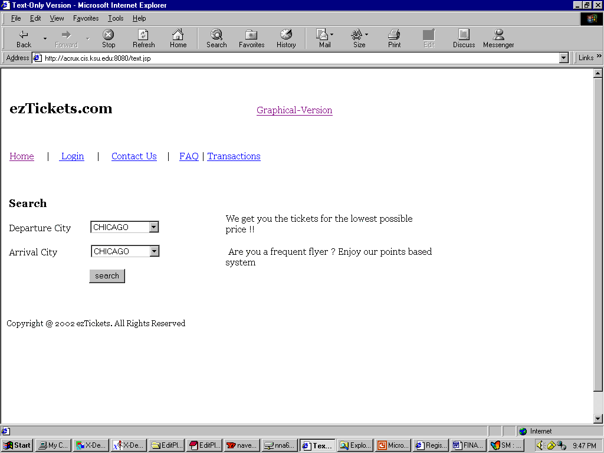

15. SNAPSHOTS OF OUR WAP-ENABLED SITE:

1. HOME PAGE :

2. USER SELECTION PAGE:

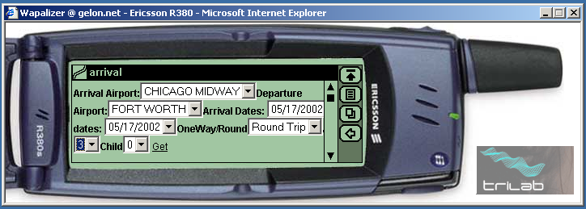

17.REFERENCES:

http://info.med.yale.edu/caim/manual/index.html
http://www.xml101.com:8081/xml/
http://www.webdevelopersjournal.com/
http://developer.iplanet.com/viewsource/marchal_xml.htm
http://www.object-arts.com/EducationCentre/Overviews/MVC.htm
http://www.w3.org/
http://www.gelon.net
http://www.delta.com
http://www.priceline.com

